3. Java Database Connectivity with 5 Steps

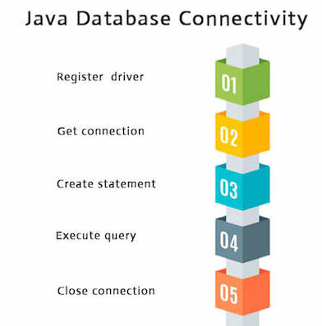
There are 5 steps to connect any java application with the database using JDBC. These steps are as follows:
- Register the Driver class
- Create connection
- Create statement
- Execute queries
- Close connection

3.1 Register the driver class
The forName() method of Class class is used to register the driver class. This method is used to dynamically load the driver class.

Syntax of forName() method
public static void forName(String className)throws ClassNotFoundException

Note: Since JDBC 4.0, explicitly registering the driver is optional. We just need to put vender's Jar in the classpath, and then JDBC driver manager can detect and load the driver automatically.

Example to register the Oracle Driver class
Here, Java program is loading oracle driver to establish database connection.
Class.forName("oracle.jdbc.driver.OracleDriver");

3.2 Create the connection object
The getConnection() method of DriverManager class is used to establish connection with the database.

Syntax of getConnection() method
public static Connection getConnection(String url) throws SQLException
public static Connection getConnection(String url,String name,String password) throws SQLException

Example to establish connection with the Oracle database
Connection con=DriverManager.getConnection( "jdbc:oracle:thin:@localhost:1521:xe","system","password");

3.3 Create the Statement object
The createStatement() method of Connection interface is used to create statement. The object of statement is responsible to execute queries with the database.
Syntax of createStatement() method
public Statement createStatement() throws SQLException

Example to create the statement object
Statement stmt=con.createStatement();

3.4 Execute the query
The executeQuery() method of Statement interface is used to execute queries to the database. This method returns the object of ResultSet that can be used to get all the records of a table.

Syntax of executeQuery() method
public ResultSet executeQuery(String sql) throws SQLException

Example to execute query
ResultSet rs = stmt.executeQuery("select * from emp");
while(rs.next()) {
System.out.println(rs.getInt(1)+" "+rs.getString(2));
}

3.5 Close the connection object
By closing connection object statement and ResultSet will be closed automatically. The close() method of Connection interface is used to close the connection.

Syntax of close() method
public void close() throws SQLException

Example to close connection
con.close();

Note: Since Java 7, JDBC has ability to use try-with-resources statement to automatically close resources of type Connection, ResultSet, and Statement.

